Conversion Factors
# Source: AI Source: Provided by: [Data Path: Persons Table -> ID Column: 1, Name_En Column: Motasem Essam] -> From: [ChatGPT] on [7/17/2026]
A Conversion Factor is a numerical ratio or fraction that expresses the equivalence between two different units measuring the same physical quantity. It is used to convert a measurement from one unit to another without changing the actual value of the quantity.
Conversion factors are fundamental in mathematics, science, engineering, medicine, manufacturing, commerce, and everyday life.

Definition
# Source: AI Source: Provided by: [Data Path: Persons Table -> ID Column: 1, Name_En Column: Motasem Essam] -> From: [ChatGPT] on [7/17/2026]
A Conversion Factor is a ratio of two equivalent measurements that is used to convert a quantity from one unit to another while preserving its physical value.

Purpose
# Source: AI Source: Provided by: [Data Path: Persons Table -> ID Column: 1, Name_En Column: Motasem Essam] -> From: [ChatGPT] on [7/17/2026]
Conversion factors are used to:
- Convert between units of measurement.
- Standardize measurements.
- Compare quantities expressed in different units.
- Simplify calculations.
- Support scientific and engineering work.
- Prevent unit-related errors.

Characteristics
# Source: AI Source: Provided by: [Data Path: Persons Table -> ID Column: 1, Name_En Column: Motasem Essam] -> From: [ChatGPT] on [7/17/2026]
Conversion factors:
- Represent equivalent quantities.
- Have a numerical value of 1, because the numerator and denominator are equal measurements expressed in different units.
- Can be multiplied or divided into calculations.
- Allow unwanted units to cancel.

General Form
# Source: AI Source: Provided by: [Data Path: Persons Table -> ID Column: 1, Name_En Column: Motasem Essam] -> From: [ChatGPT] on [7/17/2026]
A conversion factor is written as a fraction:
$$\boxed{\frac{\text{Equivalent Unit A}}{\text{Equivalent Unit B}}}$$
or
$$\boxed{\frac{\text{Equivalent Unit B}}{\text{Equivalent Unit A}}}$$
The correct orientation is chosen so that the unwanted unit cancels.

Example
# Source: AI Source: Provided by: [Data Path: Persons Table -> ID Column: 1, Name_En Column: Motasem Essam] -> From: [ChatGPT] on [7/17/2026]
Since:
1 meter = 100 centimeters
Possible conversion factors are:
$$\frac{100\text{ cm}}{1\text{ m}}$$
or
$$\frac{1\text{ m}}{100\text{ cm}}$$
Both equal 1.

Using Conversion Factors
# Source: AI Source: Provided by: [Data Path: Persons Table -> ID Column: 1, Name_En Column: Motasem Essam] -> From: [ChatGPT] on [7/17/2026]
Example 1
Convert 5 m to centimeters.
$$5\text{ m}×\frac{100\text{ cm}}{1\text{ m}}=500\text{ cm}$$
The meter units cancel.

Example 2
Convert 250 cm to meters.
$$250\text{ cm}×\frac{1\text{ m}}{100\text{ cm}}=2.5\text{ m}$$
The centimeter units cancel.

Common Conversion Factors

Length
# Source: AI Source: Provided by: [Data Path: Persons Table -> ID Column: 1, Name_En Column: Motasem Essam] -> From: [ChatGPT] on [7/17/2026]
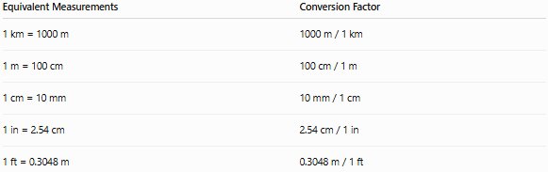
Equivalent Measurements | Conversion Factor
1 km = 1000 m | 1000 m / 1 km
1 m = 100 cm | 100 cm / 1 m
1 cm = 10 mm | 10 mm / 1 cm
1 in = 2.54 cm | 2.54 cm / 1 in
1 ft = 0.3048 m | 0.3048 m / 1 ft

Mass
# Source: AI Source: Provided by: [Data Path: Persons Table -> ID Column: 1, Name_En Column: Motasem Essam] -> From: [ChatGPT] on [7/17/2026]
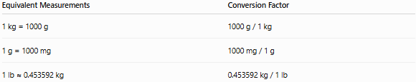
Equivalent Measurements | Conversion Factor
1 kg = 1000 g | 1000 g / 1 kg
1 g = 1000 mg | 1000 mg / 1 g
1 lb ≈ 0.453592 kg | 0.453592 kg / 1 lb

Capacity
# Source: AI Source: Provided by: [Data Path: Persons Table -> ID Column: 1, Name_En Column: Motasem Essam] -> From: [ChatGPT] on [7/17/2026]
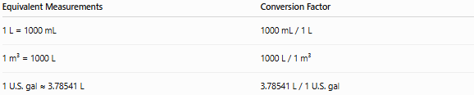
Equivalent Measurements | Conversion Factor
1 L = 1000 mL | 1000 mL / 1 L
1 m³ = 1000 L | 1000 L / 1 m³
1 U.S. gal ≈ 3.78541 L | 3.78541 L / 1 U.S. gal

Time
# Source: AI Source: Provided by: [Data Path: Persons Table -> ID Column: 1, Name_En Column: Motasem Essam] -> From: [ChatGPT] on [7/17/2026]
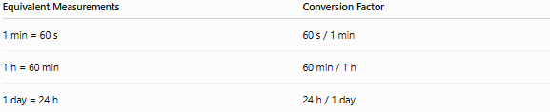
Equivalent Measurements | Conversion Factor
1 min = 60 s | 60 s / 1 min
1 h = 60 min | 60 min / 1 h
1 day = 24 h | 24 h / 1 day

Area
# Source: AI Source: Provided by: [Data Path: Persons Table -> ID Column: 1, Name_En Column: Motasem Essam] -> From: [ChatGPT] on [7/17/2026]
Area conversion factors must be squared.
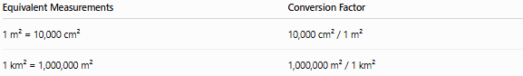
Equivalent Measurements | Conversion Factor
1 m² = 10,000 cm² | 10,000 cm² / 1 m²
1 km² = 1,000,000 m² | 1,000,000 m² / 1 km²

Volume
# Source: AI Source: Provided by: [Data Path: Persons Table -> ID Column: 1, Name_En Column: Motasem Essam] -> From: [ChatGPT] on [7/17/2026]
Volume conversion factors must be cubed.
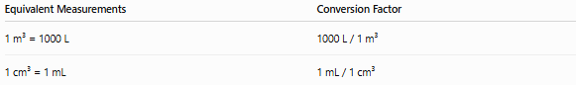
Equivalent Measurements | Conversion Factor
1 m³ = 1000 L | 1000 L / 1 m³
1 cm³ = 1 mL | 1 mL / 1 cm³

Multi-Step Conversion
# Source: AI Source: Provided by: [Data Path: Persons Table -> ID Column: 1, Name_En Column: Motasem Essam] -> From: [ChatGPT] on [7/17/2026]
Sometimes several conversion factors are used.
Example
Convert 2 km to millimeters.
$$2\text{ km}×\frac{1000\text{ m}}{1\text{ km}}×\frac{1000\text{ mm}}{1\text{ m}}=2,000,000\text{ mm}$$

Applications
# Source: AI Source: Provided by: [Data Path: Persons Table -> ID Column: 1, Name_En Column: Motasem Essam] -> From: [ChatGPT] on [7/17/2026]
Conversion factors are used in:
- Mathematics
- Physics
- Chemistry
- Engineering
- Medicine
- Manufacturing
- Construction
- Surveying
- International trade
- Everyday life

Advantages
# Source: AI Source: Provided by: [Data Path: Persons Table -> ID Column: 1, Name_En Column: Motasem Essam] -> From: [ChatGPT] on [7/17/2026]
Conversion factors:
- Preserve the physical quantity.
- Simplify unit conversions.
- Reduce calculation errors.
- Support dimensional consistency.
- Work with both SI and non-SI units.

Common Mistakes
# Source: AI Source: Provided by: [Data Path: Persons Table -> ID Column: 1, Name_En Column: Motasem Essam] -> From: [ChatGPT] on [7/17/2026]
- Reversing the conversion factor.
- Forgetting to cancel units.
- Mixing incompatible units.
- Forgetting squared or cubed conversion factors for area and volume.
- Using approximate factors when exact values are required.

Conversion Factor vs. Conversion Formula
# Source: AI Source: Provided by: [Data Path: Persons Table -> ID Column: 1, Name_En Column: Motasem Essam] -> From: [ChatGPT] on [7/17/2026]
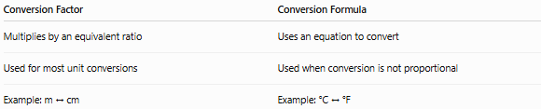
Conversion Factor | Conversion Formula
Multiplies by an equivalent ratio | Uses an equation to convert
Used for most unit conversions | Used when conversion is not proportional
Example: m ↔ cm | Example: °C ↔ °F
Example:
Temperature conversion requires formulas:
$$F=\frac{9}{5}C+32$$
rather than a simple conversion factor.

Key Points
# Source: AI Source: Provided by: [Data Path: Persons Table -> ID Column: 1, Name_En Column: Motasem Essam] -> From: [ChatGPT] on [7/17/2026]
- A Conversion Factor is a ratio of two equivalent measurements.
- It always represents a value of 1.
- The correct orientation is chosen so unwanted units cancel.
- Conversion factors are used for length, mass, time, capacity, area, volume, and many other quantities.
- Temperature is a common exception, requiring conversion formulas instead of simple conversion factors.

Conclusion
# Source: AI Source: Provided by: [Data Path: Persons Table -> ID Column: 1, Name_En Column: Motasem Essam] -> From: [ChatGPT] on [7/17/2026]
Conversion Factors are equivalent ratios that allow measurements to be converted from one unit to another without changing the physical quantity being measured. By multiplying by the appropriate conversion factor, unwanted units cancel and the desired units remain, making conversions systematic and reliable. Conversion factors are essential in science, engineering, mathematics, medicine, manufacturing, and everyday life, providing the foundation for accurate unit conversion and consistent measurement across different systems.

